Healthy Dinner Program Registration 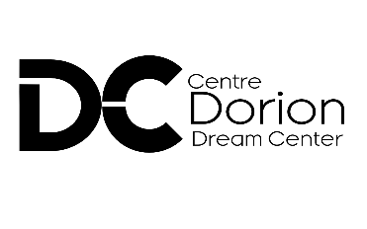
Name/ Nom
-----------------------------------------------------------------------------------------------------------------------------------
Email
----------------------------------------------------------------------------------------------------------------------------------
Phone/ Tele
-----------------------------------------------------------------------------------------------------------------------------------
Address
----------------------------------------------------------------------------------------------------------------------------------
----------------------------------------------------------------------------------------------------------------------------------
If you are filling on behalf ofanother please fill below /Si vous remplissez au nom d'un autre, veuillez remplir ci-dessous :
Name /Nom -----------------------------------------------------------------------------------------------------------------
Phone /Tele -----------------------------------------------------------------------------------------------------------------
Email: -------------------------------------------------------------------------------------------------------------------------

Reason for Meal program request/ Raison de la demande de programme de repas :
- low income or no income/ faible revenu ou pas de revenu
- Physical disability/ Handicap physique
- Senior/ Sénior
- Single Parent/ Single Parent
- Medical reason/ Raison médicale
- Other/ Autres

How did you hear about Dream center Healthy meals program?/ Comment avez-vous entendu parler du programme de repas sains Dream center?
- Friend/ Ami(e)
- Family/ Famille
- Online/ Enligne
- Other/ Autres

Preferred language/ Langue préférée
- English/ Anglais
- French/ Francais

Commentary / Commentaire

-------------------------------------------------------------------------------------------------------------------------------------------------------------------------------------------------------------------------------------------------------------------------------------------------------------------------------------------------------------------------------------------------------------------------------------------------------------------------------------------------------------------------------------------------------------------------------------------------------------------------------------------------------------------------------------------------------------------------------------------------------------------------------------------

Disclaimer: Filling out this application form does not automatically approve your eligibility. A representative from the Dorion Dream Center will be contacting you for more details. / Avis de non-responsabilité : remplir ce formulaire de demande n'approuve pas automatiquement votre admissibilité. Un représentant du Dorion Dream Center communiquera avec vous pour plus de détails.

WWW.DORIONDREAMCENTER.COM
450-455-4532

